**Search Algorithms Write-Up**

The actual implementation of the three algorithms was not too difficult overall. Insertion sort and bubble sort were just a translation of pseudo-code from the book. The modified version of the bubble sort algorithm was more difficult for sure. I had to take a look at various implementations online before I truly understood it, but once I did, I was able to make my own flavor of it that updates the range to sort during the alternating passes. One of the biggest difficulties I faced occurred during testing. My two bubble sorts were performing identically in my testing program but producing the expected different results when tested individually. After hours of troubleshooting, it was an issue with the arrays I was passing into the algorithms, not the algorithms or counters themselves.

The visual and console results generally agree with the analysis in the book for these algorithms. Their outputs are all of similar shape. With the best and worst case scenarios (pre sorted and opposite of sorted), the algorithms perform identically or near identically.

Monte Carlo Results (Red is Insertion, Bubble is Blue, Bubble2 is Green) (irregular graph shapes are due to scaling) 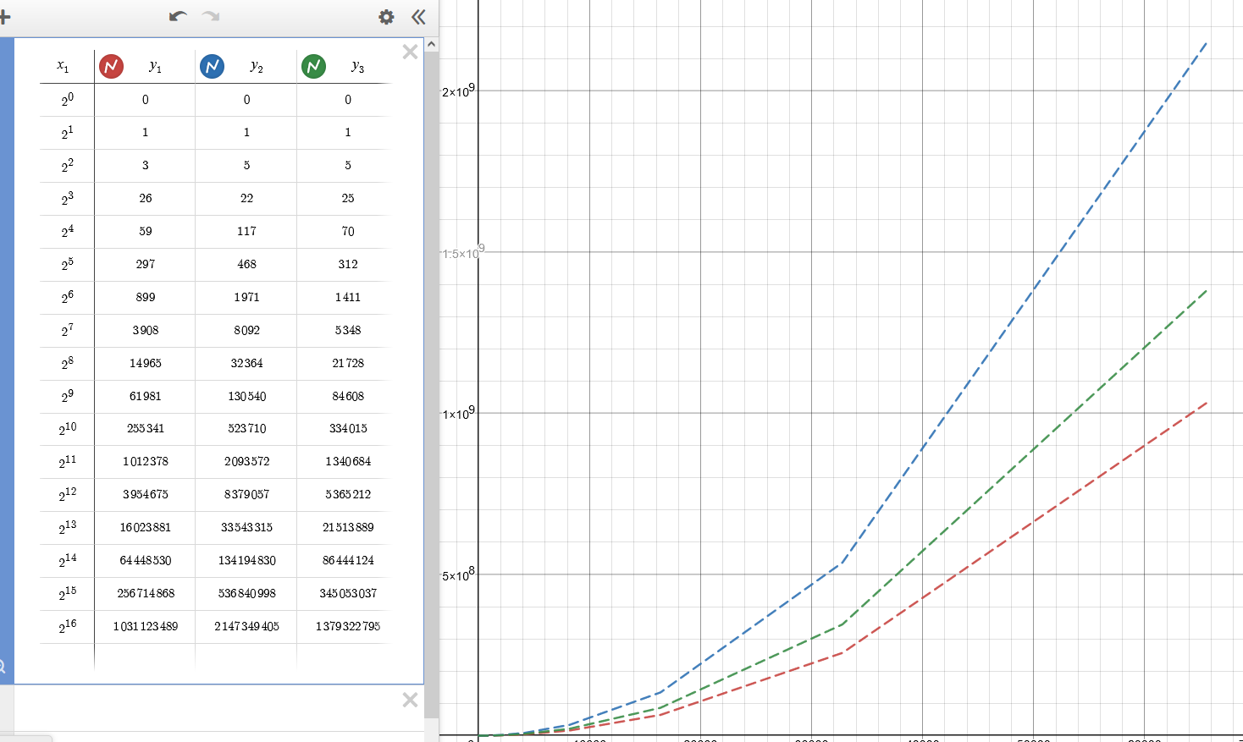

Ascending Results

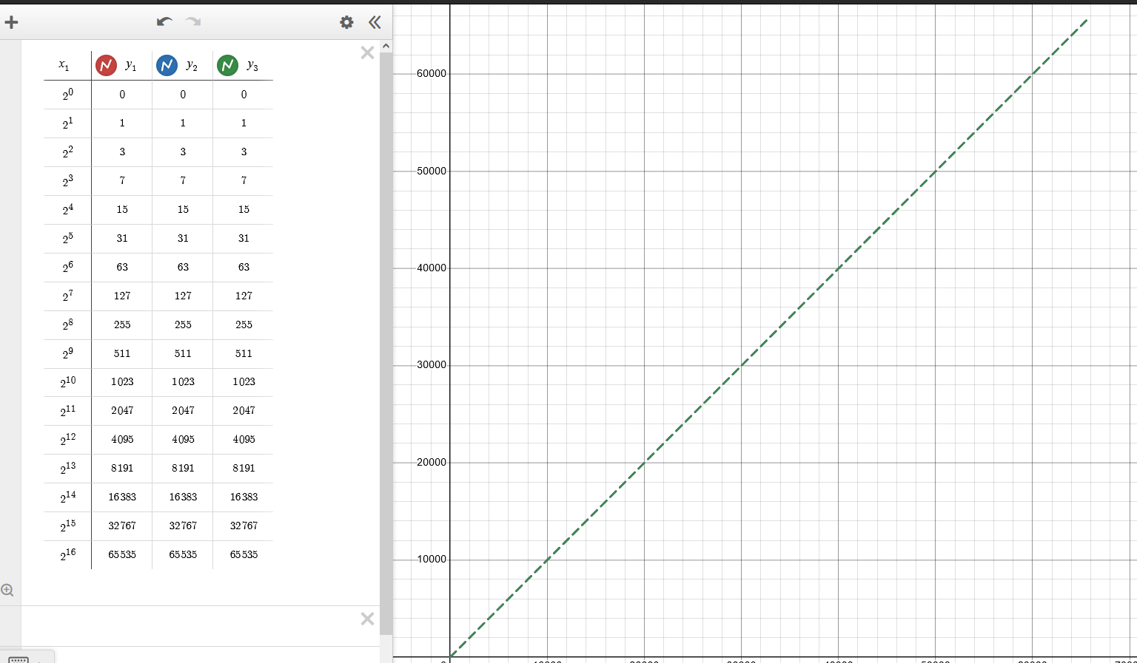

Descending Results



